**Data:**

* **No. of observation**=n=36
* **Yearly Data**=1980-2015
* **Variables:** GDP, REER, Crude Oil, US-Inflation
* **Data:**

|  |  |  |  |  |
| --- | --- | --- | --- | --- |
| **Year** | **lnREER** | **US Inflation** | **lnGDP** | **lnCurde Oil** |
| 1980 | 5.31 | 13.58 | 24.35 | 3.62 |
| 1981 | 5.43 | 10.35 | 24.30 | 3.58 |
| 1982 | 5.35 | 6.16 | 24.18 | 3.46 |
| 1983 | 5.31 | 5.39 | 24.09 | 3.37 |
| 1984 | 5.33 | 4.83 | 24.08 | 3.36 |
| 1985 | 5.26 | 4.3 | 24.02 | 3.29 |
| 1986 | 5.07 | 4.25 | 23.39 | 2.67 |
| 1987 | 4.95 | 4.08 | 23.60 | 2.88 |
| 1988 | 4.92 | 3.85 | 23.42 | 2.70 |
| 1989 | 4.85 | 3.66 | 23.63 | 2.91 |
| 1990 | 4.80 | 3.55 | 23.87 | 3.14 |
| 1991 | 4.78 | 3.39 | 23.73 | 3.01 |
| 1992 | 4.76 | 3.38 | 23.68 | 2.96 |
| 1993 | 4.75 | 3.24 | 23.54 | 2.82 |
| 1994 | 4.74 | 3.22 | 23.47 | 2.75 |
| 1995 | 4.73 | 3.16 | 23.54 | 2.82 |
| 1996 | 4.71 | 3.03 | 23.74 | 3.02 |
| 1997 | 4.72 | 2.96 | 23.65 | 2.93 |
| 1998 | 4.73 | 2.93 | 23.20 | 2.48 |
| 1999 | 4.66 | 2.85 | 23.53 | 2.81 |
| 2000 | 4.64 | 2.83 | 24.03 | 3.31 |
| 2001 | 4.54 | 2.81 | 23.86 | 3.14 |
| 2002 | 4.58 | 2.68 | 23.85 | 3.13 |
| 2003 | 4.55 | 2.61 | 24.04 | 3.32 |
| 2004 | 4.54 | 2.34 | 24.35 | 3.63 |
| 2005 | 4.57 | 2.27 | 24.64 | 3.91 |
| 2006 | 4.60 | 2.19 | 24.79 | 4.07 |
| 2007 | 4.59 | 2.07 | 24.89 | 4.16 |
| 2008 | 4.55 | 1.91 | 25.24 | 4.52 |
| 2009 | 4.56 | 1.64 | 24.70 | 3.98 |
| 2010 | 4.61 | 1.62 | 24.99 | 4.27 |
| 2011 | 4.63 | 1.59 | 25.19 | 4.47 |
| 2012 | 4.65 | 1.55 | 25.18 | 4.46 |
| 2013 | 4.63 | 1.47 | 25.24 | 4.51 |
| 2014 | 4.70 | 0.12 | 25.17 | 4.45 |
| 2015 | 4.79 | -0.34 | 24.46 | 3.73 |

**Basic Linear Regression:**

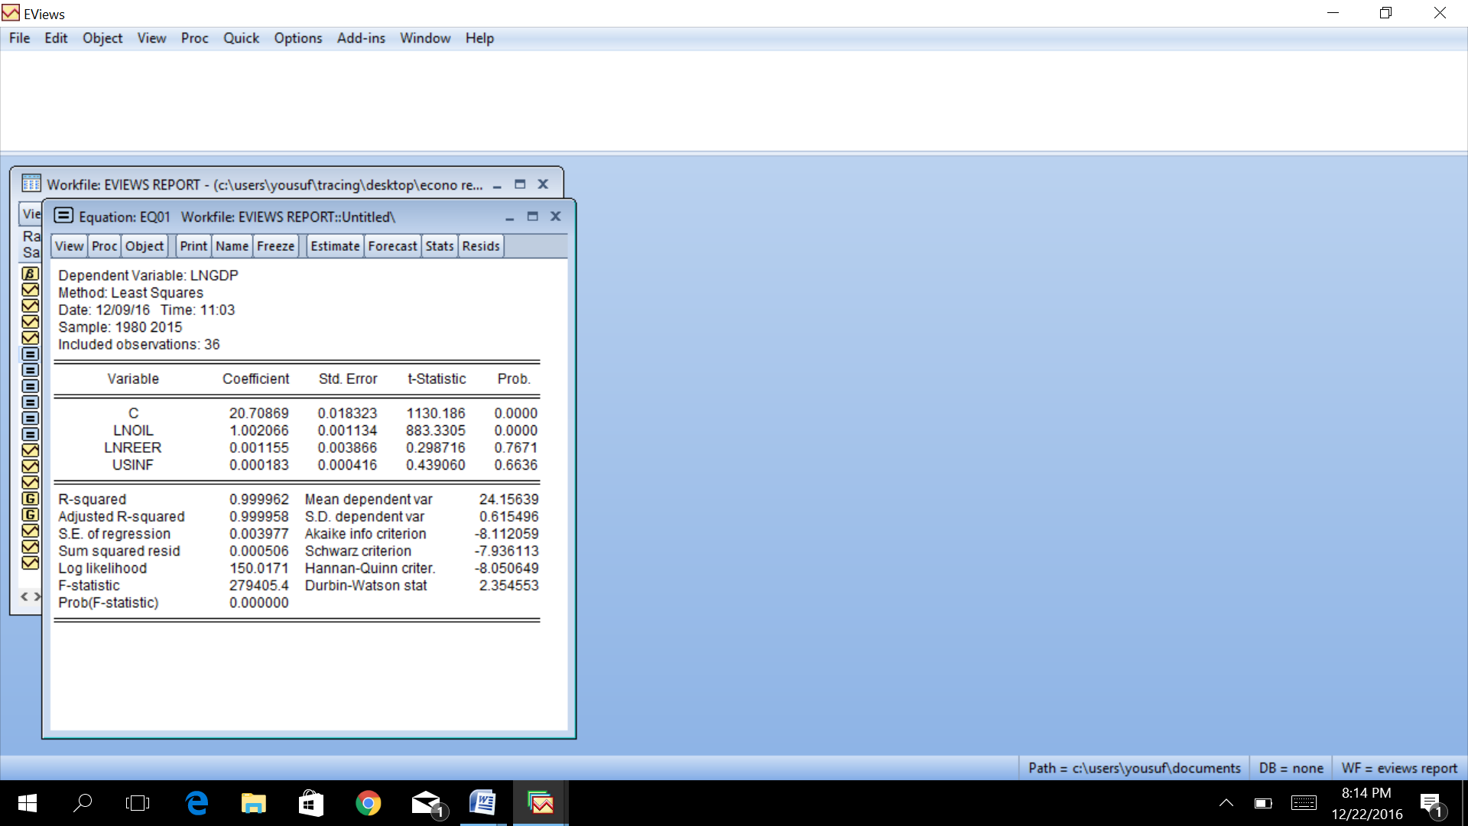

**INTERPETATION:**

Above regression reflects F statistics of 279405.4, which depicts that the overall model is reliable. Adjusted R square explains the explanatory power of the model. In other words 99% of variation in GDP is explained by the independent variables in the model.

**LNOIL:** Explains that 1% increase in crude oil price leads to 1.0% increase in GDP Growth.

**LNREER:** Explains that 1% increase in real effective exchange rate leads to 0.001% increase in GDP Growth.

**USINF:** Explains that 1% increase in US Inflation leads to 0.0001% increase in GDP Growth.

Finally, High R2 & few Significant (t) ratios indicates there may exist multicollinearity between independent variables. We shall try to detect this problem.

**Multicolinerity:**

**LNGDP = C+LNOIL+LNREER+USINF**

|  |  |  |  |  |
| --- | --- | --- | --- | --- |
| Dependent Variable: LNGDP | | |  |  |
| Method: Least Squares | | |  |  |
| Date: 12/09/16 Time: 11:03 | | |  |  |
| Sample: 1980 2015 | | |  |  |
| Included observations: 36 | | |  |  |
|  |  |  |  |  |
|  |  |  |  |  |
| Variable | Coefficient | Std. Error | t-Statistic | Prob. |
|  |  |  |  |  |
|  |  |  |  |  |
| C | 20.70869 | 0.018323 | 1130.186 | 0.0000 |
| LNOIL | 1.002066 | 0.001134 | 883.3305 | 0.0000 |
| LNREER | 0.001155 | 0.003866 | 0.298716 | 0.7671 |
| USINF | 0.000183 | 0.000416 | 0.439060 | 0.6636 |
|  |  |  |  |  |
|  |  |  |  |  |
| R-squared | 0.999962 | Mean dependent var | | 24.15639 |
| Adjusted R-squared | 0.999958 | S.D. dependent var | | 0.615496 |
| S.E. of regression | 0.003977 | Akaike info criterion | | -8.112059 |
| Sum squared resid | 0.000506 | Schwarz criterion | | -7.936113 |
| Log likelihood | 150.0171 | Hannan-Quinn criter. | | -8.050649 |
| F-statistic | 279405.4 | Durbin-Watson stat | | 2.354553 |
| Prob(F-statistic) | 0.000000 |  |  |  |
|  |  |  |  |  |
|  |  |  |  |  |

**Interpretation**

**High R square and few significant ratios**

High value of R Square and few significant (t) ratios indicate that there may exist muliticollinearity among above regressors.

**1. Auxilary relationship:**

**Applying mathord by making LNREER as dependent variable:**

|  |  |  |  |  |
| --- | --- | --- | --- | --- |
| Dependent Variable: LNREER | | |  |  |
| Method: Least Squares | | |  |  |
| Date: 12/25/16 Time: 22:41 | | |  |  |
| Sample: 1980 2015 | | |  |  |
| Included observations: 36 | | |  |  |
|  |  |  |  |  |
|  |  |  |  |  |
| Variable | Coefficient | Std. Error | t-Statistic | Prob. |
|  |  |  |  |  |
|  |  |  |  |  |
| C | 4.608997 | 0.192343 | 23.96238 | 0.0000 |
| LNOIL | -0.022555 | 0.050929 | -0.442868 | 0.6608 |
| USINF | 0.080273 | 0.012484 | 6.430204 | 0.0000 |
|  |  |  |  |  |
|  |  |  |  |  |
| R-squared | 0.581930 | Mean dependent var | | 4.802500 |
| Adjusted R-squared | 0.556593 | S.D. dependent var | | 0.268938 |
| S.E. of regression | 0.179083 | Akaike info criterion | | -0.522281 |
| Sum squared resid | 1.058333 | Schwarz criterion | | -0.390321 |
| Log likelihood | 12.40105 | Hannan-Quinn criter. | | -0.476223 |
| F-statistic | 22.96712 | Durbin-Watson stat | | 0.318930 |
| Prob(F-statistic) | 0.000001 |  |  |  |
|  |  |  |  |  |
|  |  |  |  |  |

**Interpretation**

Having applied auxiliary regression by taking one of the regressors LNREER as dependent variable, it appears that F statistics is highly significant which confirms that mulicollinearity exists.

**Make LNOIL as a dependent variable:**

|  |  |  |  |  |
| --- | --- | --- | --- | --- |
| Dependent Variable: LNOIL | | |  |  |
| Method: Least Squares | | |  |  |
| Date: 12/25/16 Time: 23:13 | | |  |  |
| Sample: 1980 2015 | | |  |  |
| Included observations: 36 | | |  |  |
|  |  |  |  |  |
|  |  |  |  |  |
| Variable | Coefficient | Std. Error | t-Statistic | Prob. |
|  |  |  |  |  |
|  |  |  |  |  |
| C | 4.829850 | 2.683076 | 1.800117 | 0.0810 |
| LNREER | -0.261951 | 0.591487 | -0.442868 | 0.6608 |
| USINF | -0.040701 | 0.063463 | -0.641327 | 0.5257 |
|  |  |  |  |  |
|  |  |  |  |  |
| R-squared | 0.069703 | Mean dependent var | | 3.434444 |
| Adjusted R-squared | 0.013321 | S.D. dependent var | | 0.614405 |
| S.E. of regression | 0.610299 | Akaike info criterion | | 1.929921 |
| Sum squared resid | 12.29135 | Schwarz criterion | | 2.061881 |
| Log likelihood | -31.73858 | Hannan-Quinn criter. | | 1.975978 |
| F-statistic | 1.236270 | Durbin-Watson stat | | 0.222312 |
| Prob(F-statistic) | 0.303569 |  |  |  |
|  |  |  |  |  |
|  |  |  |  |  |

**Interpretation**

Having applied auxiliary regression by taking other regressors LNOIL as dependent variable, it appears that F statistics is highly significant which confirms that mulicollinearity exists.

**make USINF as a dependent variable:**

|  |  |  |  |  |
| --- | --- | --- | --- | --- |
| Dependent Variable: USINF | | |  |  |
| Method: Least Squares | | |  |  |
| Date: 12/25/16 Time: 23:16 | | |  |  |
| Sample: 1980 2015 | | |  |  |
| Included observations: 36 | | |  |  |
|  |  |  |  |  |
|  |  |  |  |  |
| Variable | Coefficient | Std. Error | t-Statistic | Prob. |
|  |  |  |  |  |
|  |  |  |  |  |
| C | -28.85774 | 5.789198 | -4.984756 | 0.0000 |
| LNREER | 6.928073 | 1.077427 | 6.430204 | 0.0000 |
| LNOIL | -0.302458 | 0.471613 | -0.641327 | 0.5257 |
|  |  |  |  |  |
|  |  |  |  |  |
| R-squared | 0.584623 | Mean dependent var | | 3.375556 |
| Adjusted R-squared | 0.559448 | S.D. dependent var | | 2.506552 |
| S.E. of regression | 1.663700 | Akaike info criterion | | 3.935621 |
| Sum squared resid | 91.34065 | Schwarz criterion | | 4.067581 |
| Log likelihood | -67.84117 | Hannan-Quinn criter. | | 3.981678 |
| F-statistic | 23.22293 | Durbin-Watson stat | | 0.432075 |
| Prob(F-statistic) | 0.000001 |  |  |  |
|  |  |  |  |  |
|  |  |  |  |  |

**Interpretation:**

Having applied auxiliary regression by taking other regressors USINF as dependent variable, it appears that F statistics is highly significant which confirms that mulicollinearity exists.

**2.Principal Component Methord:**

In SLRM the regressors are not showing signifficant results of f statics therefore principal compnent create to remove the muticollinarity in the variables.

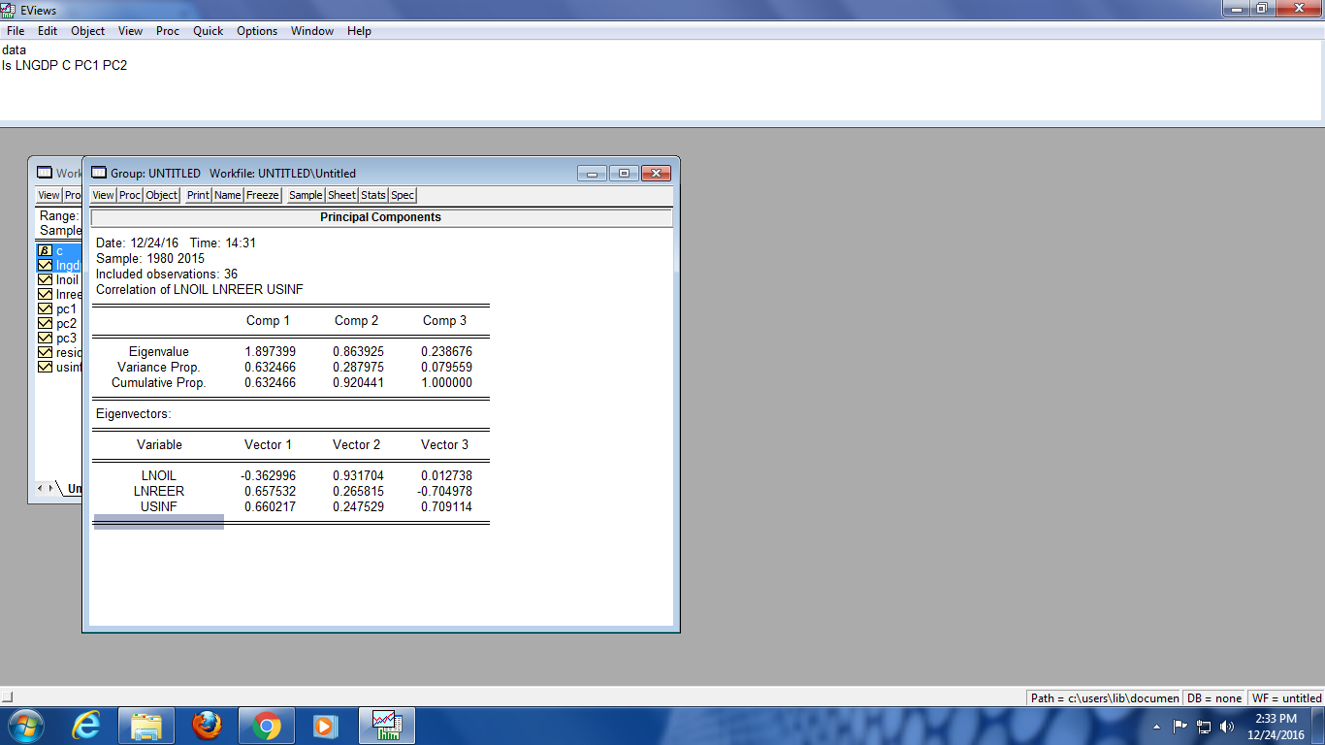

|  |  |  |  |  |
| --- | --- | --- | --- | --- |
| **Interpretation** |  |  |  |  |

The first PC has a variance of 1.89 (eigenvalue) and accounts for 63.2% variation in all the regressors. The second PC has a variance of 0.86 accounting for 28.7% variation in all other regressors. Among all three regressors, only PC1 and PC2 seem to be important quantitatively.

**Step 2:**

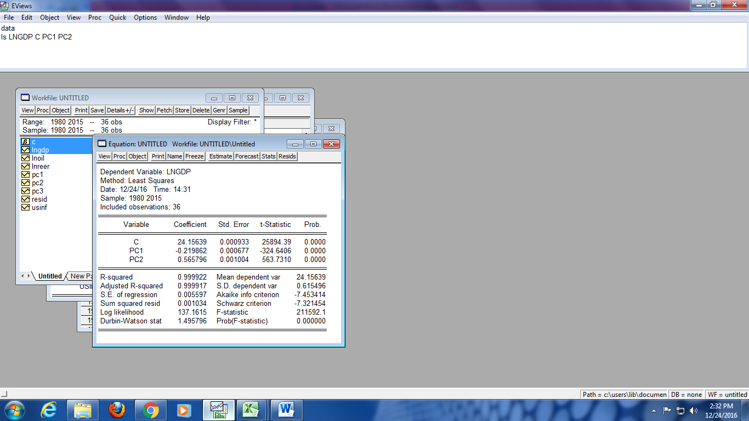

**Hetroscdasticity:**

**1. Graph Histogram of Squared Residual:**

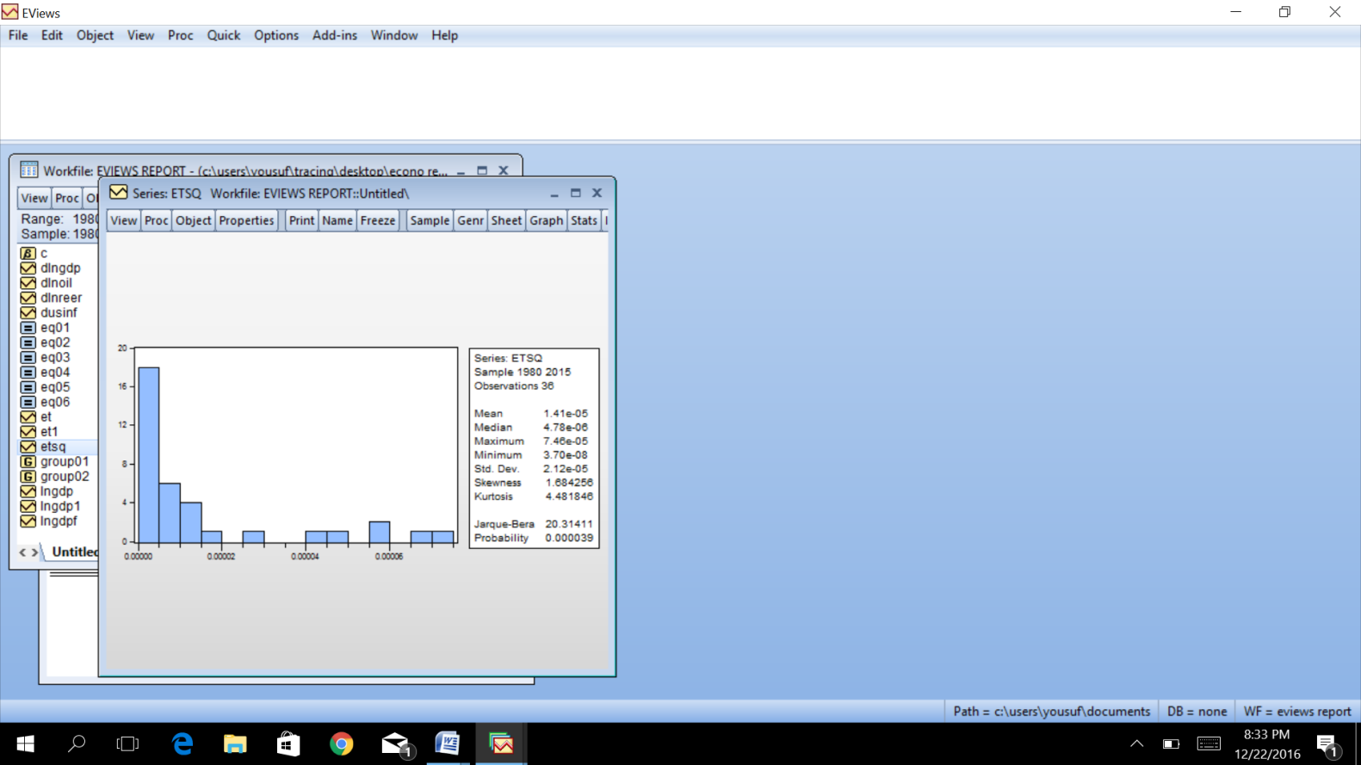

**Interpetation:**

Skeweness of the squre root represent the data is may be hetroscdastic.

**2. Graph Square Residual against Predicted Y:**

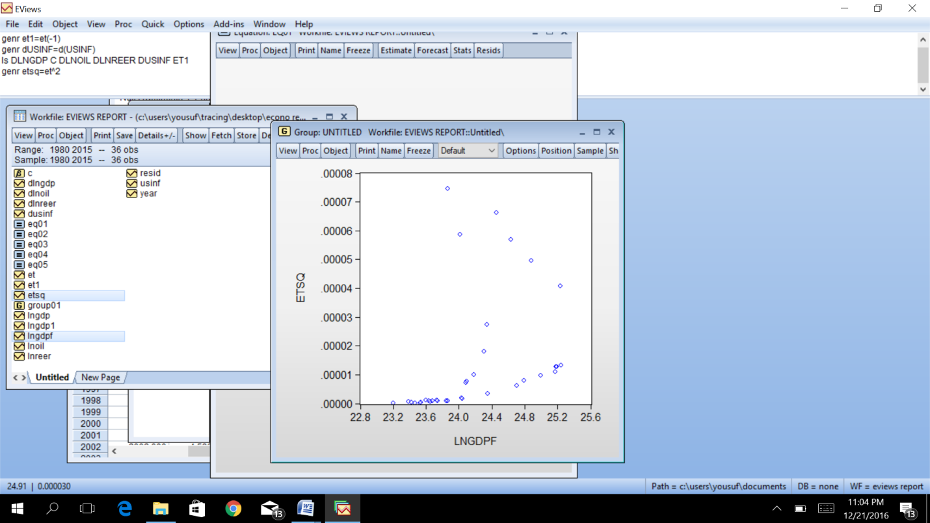

**Interpetation:**

It seems that there is a systematic relationship between the squared residual and the estmated value of GDP.

**3. Breush-Pagan Test:**

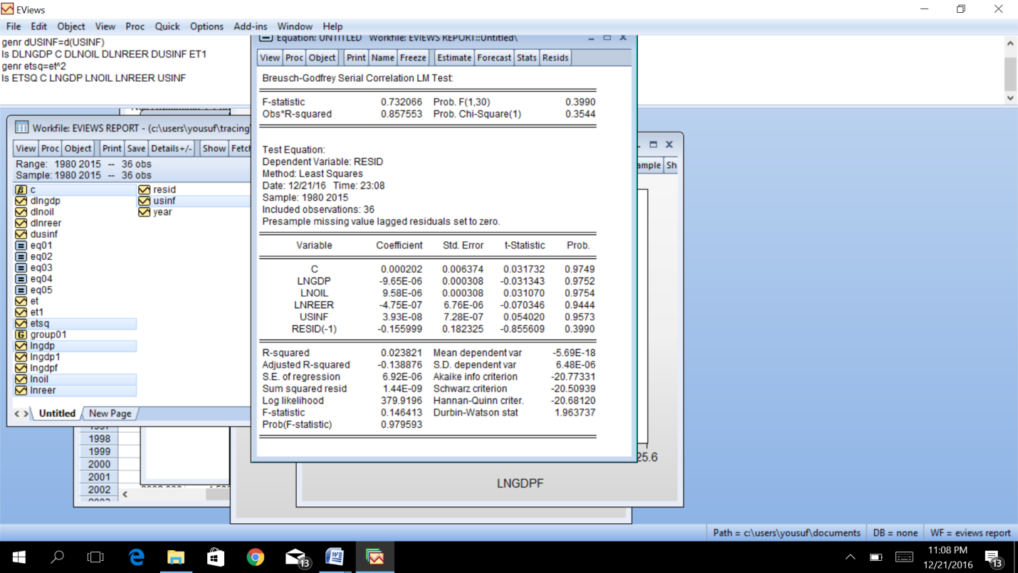

**Interpretation**

Applying Breusch Pagan (BP) test of Heteroscedasticity, Null hypothesis is rejected here as well. Hence, in the given regression model the basic assumption of CLRM which is equal variance of error terms is violated. Therefore there exist heteroscedasticity.

|  |  |  |  |  |
| --- | --- | --- | --- | --- |
| Dependent Variable: ETSQ | | |  |  |
| Method: Least Squares | | |  |  |
| Date: 12/25/16 Time: 23:52 | | |  |  |
| Sample: 1980 2015 | | |  |  |
| Included observations: 36 | | |  |  |
|  |  |  |  |  |
|  |  |  |  |  |
| Variable | Coefficient | Std. Error | t-Statistic | Prob. |
|  |  |  |  |  |
|  |  |  |  |  |
| C | -0.000151 | 9.24E-05 | -1.637371 | 0.1114 |
| LNOIL | 1.37E-05 | 5.72E-06 | 2.393802 | 0.0227 |
| LNREER | 2.58E-05 | 1.95E-05 | 1.320520 | 0.1960 |
| USINF | -1.58E-06 | 2.10E-06 | -0.750636 | 0.4584 |
|  |  |  |  |  |
|  |  |  |  |  |
| R-squared | 0.181306 | Mean dependent var | | 1.41E-05 |
| Adjusted R-squared | 0.104554 | S.D. dependent var | | 2.12E-05 |
| S.E. of regression | 2.01E-05 | Akaike info criterion | | -18.69114 |
| Sum squared resid | 1.29E-08 | Schwarz criterion | | -18.51519 |
| Log likelihood | 340.4404 | Hannan-Quinn criter. | | -18.62973 |
| F-statistic | 2.362218 | Durbin-Watson stat | | 2.302208 |
| Prob(F-statistic) | 0.089721 |  |  |  |
|  |  |  |  |  |
|  |  |  |  |  |

**Interpretation**

Applying White Test of Heteroscedasticity, Null hypothesis appear to be rejected. Hence, in the given regression model the basic assumption of CLRM which is equal variance of error terms is violated. Therefore there exist heteroscedasticity.

**Remidial Measures of Hetroscdasticity:**

**1. White Hetroscdasticity consistent standard error:**

|  |  |  |  |  |
| --- | --- | --- | --- | --- |
| Dependent Variable: LNGDP | | |  |  |
| Method: Least Squares | | |  |  |
| Date: 12/25/16 Time: 22:56 | | |  |  |
| Sample: 1980 2015 | | |  |  |
| Included observations: 36 | | |  |  |
| White heteroskedasticity-consistent standard errors & covariance | | | | |
|  |  |  |  |  |
|  |  |  |  |  |
| Variable | Coefficient | Std. Error | t-Statistic | Prob. |
|  |  |  |  |  |
|  |  |  |  |  |
| C | 20.70869 | 0.020864 | 992.5468 | 0.0000 |
| LNOIL | 1.002066 | 0.001041 | 962.6370 | 0.0000 |
| LNREER | 0.001155 | 0.004740 | 0.243656 | 0.8091 |
| USINF | 0.000183 | 0.000601 | 0.303935 | 0.7631 |
|  |  |  |  |  |
|  |  |  |  |  |
| R-squared | 0.999962 | Mean dependent var | | 24.15639 |
| Adjusted R-squared | 0.999958 | S.D. dependent var | | 0.615496 |
| S.E. of regression | 0.003977 | Akaike info criterion | | -8.112059 |
| Sum squared resid | 0.000506 | Schwarz criterion | | -7.936113 |
| Log likelihood | 150.0171 | Hannan-Quinn criter. | | -8.050649 |
| F-statistic | 279405.4 | Durbin-Watson stat | | 2.354553 |
| Prob(F-statistic) | 0.000000 |  |  |  |
|  |  |  |  |  |
|  |  |  |  |  |

**Interpetation:**

Applying remedial White Heteroscedasticity-consistent standard errors or robust standard errors test we observe that although coefficients remains the same as original models, however, standard errors have changed which leads to change in ***t*** values.

**AUTOCORRELATION**

**Detection through Graph of Current vs lagged Residuals**



**Interpretation**

Pattern in scatter diagram show that error term of different time periods might be correlated or following specific pattern.

**AUTOCORRELATION**

**Detection through Breusch GodFrey (BG) test**

|  |  |  |  |  |
| --- | --- | --- | --- | --- |
| Breusch-Godfrey Serial Correlation LM Test: | | | |  |
|  |  |  |  |  |
|  |  |  |  |  |
| F-statistic | 2.913853 | Prob. F(1,31) | | 0.0978 |
| Obs*R-squared | 3.093093 | Prob. Chi-Square(1) | | 0.0786 |
|  |  |  |  |  |
|  |  |  |  |  |
|  |  |  |  |  |
| Test Equation: | |  |  |  |
| Dependent Variable: RESID | | |  |  |
| Method: Least Squares | | |  |  |
| Date: 12/26/16 Time: 00:01 | | |  |  |
| Sample: 1980 2015 | | |  |  |
| Included observations: 36 | | |  |  |
| Presample missing value lagged residuals set to zero. | | | | |
|  |  |  |  |  |
|  |  |  |  |  |
| Variable | Coefficient | Std. Error | t-Statistic | Prob. |
|  |  |  |  |  |
|  |  |  |  |  |
| C | 0.003272 | 0.017902 | 0.182801 | 0.8561 |
| USINF | 0.000102 | 0.000409 | 0.249352 | 0.8047 |
| LNREER | -0.000747 | 0.003781 | -0.197552 | 0.8447 |
| LNOIL | -2.95E-05 | 0.001102 | -0.026802 | 0.9788 |
| RESID(-1) | -0.318650 | 0.186672 | -1.707001 | 0.0978 |
|  |  |  |  |  |
|  |  |  |  |  |
| R-squared | 0.085919 | Mean dependent var | | -2.97E-15 |
| Adjusted R-squared | -0.032027 | S.D. dependent var | | 0.003803 |
| S.E. of regression | 0.003863 | Akaike info criterion | | -8.146340 |
| Sum squared resid | 0.000463 | Schwarz criterion | | -7.926407 |
| Log likelihood | 151.6341 | Hannan-Quinn criter. | | -8.069577 |
| F-statistic | 0.728463 | Durbin-Watson stat | | 1.737653 |
| Prob(F-statistic) | 0.579352 |  |  |  |
|  |  |  |  |  |
|  |  |  |  |  |

**Interpretation**

Applying Breusch Godfrey test , we can conclude that Null Hypothesis of no autocorrelation is rejected and the given model violates the basic CLRM assumptions that error terms of different time periods are unrelated to each other.

**AUTOCORRELATION**

**REMEDIAL MEASURES**

**First Differnce Transformation:**

|  |  |  |  |  |
| --- | --- | --- | --- | --- |
| Breusch-Godfrey Serial Correlation LM Test: | | | |  |
|  |  |  |  |  |
|  |  |  |  |  |
| F-statistic | 21.88490 | Prob. F(1,31) | | 0.0001 |
| Obs*R-squared | 14.34905 | Prob. Chi-Square(1) | | 0.0002 |
|  |  |  |  |  |
|  |  |  |  |  |
|  |  |  |  |  |
| Test Equation: | |  |  |  |
| Dependent Variable: RESID | | |  |  |
| Method: Least Squares | | |  |  |
| Date: 12/26/16 Time: 01:20 | | |  |  |
| Sample: 1981 2015 | | |  |  |
| Included observations: 35 | | |  |  |
| Presample missing value lagged residuals set to zero. | | | | |
|  |  |  |  |  |
|  |  |  |  |  |
| Variable | Coefficient | Std. Error | t-Statistic | Prob. |
|  |  |  |  |  |
|  |  |  |  |  |
| DLNOIL | 0.001572 | 0.002947 | 0.533249 | 0.5977 |
| DLNREER | -0.003975 | 0.013192 | -0.301346 | 0.7652 |
| DUSINF | 0.000222 | 0.000839 | 0.264794 | 0.7929 |
| RESID(-1) | -0.685085 | 0.146444 | -4.678130 | 0.0001 |
|  |  |  |  |  |
|  |  |  |  |  |
| R-squared | 0.409973 | Mean dependent var | | 0.000464 |
| Adjusted R-squared | 0.352873 | S.D. dependent var | | 0.005816 |
| S.E. of regression | 0.004678 | Akaike info criterion | | -7.784559 |
| Sum squared resid | 0.000678 | Schwarz criterion | | -7.606805 |
| Log likelihood | 140.2298 | Hannan-Quinn criter. | | -7.723199 |
| Durbin-Watson stat | 2.054488 |  |  |  |
|  |  |  |  |  |
|  |  |  |  |  |

**Interpretation:**

**Generalized Transformation:**

**STEP 1**

|  |  |  |  |  |
| --- | --- | --- | --- | --- |
| Dependent Variable: ET | | |  |  |
| Method: Least Squares | | |  |  |
| Date: 12/26/16 Time: 01:27 | | |  |  |
| Sample (adjusted): 1981 2015 | | |  |  |
| Included observations: 35 after adjustments | | | |  |
|  |  |  |  |  |
|  |  |  |  |  |
| Variable | Coefficient | Std. Error | t-Statistic | Prob. |
|  |  |  |  |  |
|  |  |  |  |  |
| ET1 | -0.310229 | 0.170840 | -1.815906 | 0.0782 |
|  |  |  |  |  |
|  |  |  |  |  |
| R-squared | 0.086926 | Mean dependent var | | -0.000149 |
| Adjusted R-squared | 0.086926 | S.D. dependent var | | 0.003750 |
| S.E. of regression | 0.003583 | Akaike info criterion | | -8.396907 |
| Sum squared resid | 0.000437 | Schwarz criterion | | -8.352468 |
| Log likelihood | 147.9459 | Hannan-Quinn criter. | | -8.381566 |
| Durbin-Watson stat | 1.732111 |  |  |  |
|  |  |  |  |  |
|  |  |  |  |  |

**STEP 2:**

|  |  |  |  |  |
| --- | --- | --- | --- | --- |
| Dependent Variable: LNGDP*-0.31-LNGDP(-1) | | | |  |
| Method: Least Squares | | |  |  |
| Date: 12/26/16 Time: 01:25 | | |  |  |
| Sample (adjusted): 1981 2015 | | |  |  |
| Included observations: 35 after adjustments | | | |  |
|  |  |  |  |  |
|  |  |  |  |  |
| Variable | Coefficient | Std. Error | t-Statistic | Prob. |
|  |  |  |  |  |
|  |  |  |  |  |
| C | -27.13556 | 0.017681 | -1534.699 | 0.0000 |
| LNOIL*-0.31-LNOIL(-1) | 1.001958 | 0.000800 | 1252.377 | 0.0000 |
| LNREER*-0.31-LNREER(-1) | -5.06E-05 | 0.002900 | -0.017460 | 0.9862 |
| USINF*-0.31-USINF(-1) | 0.000317 | 0.000342 | 0.927768 | 0.3607 |
|  |  |  |  |  |
|  |  |  |  |  |
| R-squared | 0.999982 | Mean dependent var | | -31.63448 |
| Adjusted R-squared | 0.999980 | S.D. dependent var | | 0.800926 |
| S.E. of regression | 0.003574 | Akaike info criterion | | -8.323068 |
| Sum squared resid | 0.000396 | Schwarz criterion | | -8.145314 |
| Log likelihood | 149.6537 | Hannan-Quinn criter. | | -8.261707 |
| F-statistic | 569158.0 | Durbin-Watson stat | | 1.792614 |
| Prob(F-statistic) | 0.000000 |  |  |  |
|  |  |  |  |  |
|  |  |  |  |  |

**Interpretation:**

***The Newey-West method of Correcting OLS standard errors***

|  |  |  |  |  |
| --- | --- | --- | --- | --- |
| Dependent Variable: LNGDP | | |  |  |
| Method: Least Squares | | |  |  |
| Date: 12/25/16 Time: 20:59 | | |  |  |
| Sample: 1980 2015 | | |  |  |
| Included observations: 36 | | |  |  |
| HAC standard errors & covariance (Bartlett kernel, Newey-West fixed | | | | |
| bandwidth = 4.0000) | | |  |  |
|  |  |  |  |  |
|  |  |  |  |  |
| Variable | Coefficient | Std. Error | t-Statistic | Prob. |
|  |  |  |  |  |
|  |  |  |  |  |
| C | 20.70869 | 0.019198 | 1078.669 | 0.0000 |
| LNOIL | 1.002066 | 0.000816 | 1228.587 | 0.0000 |
| LNREER | 0.001155 | 0.004251 | 0.271641 | 0.7876 |
| USINF | 0.000183 | 0.000466 | 0.392093 | 0.6976 |
|  |  |  |  |  |
|  |  |  |  |  |
| R-squared | 0.999962 | Mean dependent var | | 24.15639 |
| Adjusted R-squared | 0.999958 | S.D. dependent var | | 0.615496 |
| S.E. of regression | 0.003977 | Akaike info criterion | | -8.112059 |
| Sum squared resid | 0.000506 | Schwarz criterion | | -7.936113 |
| Log likelihood | 150.0171 | Hannan-Quinn criter. | | -8.050649 |
| F-statistic | 279405.4 | Durbin-Watson stat | | 2.354553 |
| Prob(F-statistic) | 0.000000 |  |  |  |
|  |  |  |  |  |
|  |  |  |  |  |

**Interpretation**

Applying The Newey-West method of Correcting OLS standard errors, it is observed that values of standard errors substantially differ from the values of standard errors in original regression (page # 1). This indicates that autocorrelation was serious problem in the given data.

**Model misspecification:**

**1. Model misspecification test through Ramsey Reset Test**

|  |  |  |  |  |
| --- | --- | --- | --- | --- |
| **Ramsey RESET Test** | | |  |  |
| Equation: EQ01 | | |  |  |
| Specification: LNGDP C LNOIL LNREER USINF | | | |  |
| Omitted Variables: Squares of fitted values | | | |  |
|  |  |  |  |  |
|  |  |  |  |  |
|  | Value | df | Probability |  |
| t-statistic | 1.123796 | 31 | 0.2697 |  |
| F-statistic | 1.262918 | (1, 31) | 0.2697 |  |
| Likelihood ratio | 1.437528 | 1 | 0.2305 |  |
|  |  |  |  |  |
|  |  |  |  |  |
| F-test summary: | | |  |  |
|  | Sum of Sq. | df | Mean Squares |  |
| Test SSR | 1.98E-05 | 1 | 1.98E-05 |  |
| Restricted SSR | 0.000506 | 32 | 1.58E-05 |  |
| Unrestricted SSR | 0.000486 | 31 | 1.57E-05 |  |
| Unrestricted SSR | 0.000486 | 31 | 1.57E-05 |  |
|  |  |  |  |  |
|  |  |  |  |  |
| LR test summary: | | |  |  |
|  | Value | df |  |  |
| Restricted LogL | 150.0171 | 32 |  |  |
| Unrestricted LogL | 150.7358 | 31 |  |  |
|  |  |  |  |  |
|  |  |  |  |  |
|  |  |  |  |  |
| Unrestricted Test Equation: | | |  |  |
| Dependent Variable: LNGDP | | |  |  |
| Method: Least Squares | | |  |  |
| Date: 12/25/16 Time: 12:16 | | |  |  |
| Sample: 1980 2015 | | |  |  |
| Included observations: 36 | | |  |  |
|  |  |  |  |  |
|  |  |  |  |  |
| Variable | Coefficient | Std. Error | t-Statistic | Prob. |
|  |  |  |  |  |
|  |  |  |  |  |
| C | 21.75108 | 0.927740 | 23.44522 | 0.0000 |
| LNOIL | 1.123538 | 0.108097 | 10.39383 | 0.0000 |
| LNREER | 0.000899 | 0.003857 | 0.233092 | 0.8172 |
| USINF | 0.000112 | 0.000419 | 0.266898 | 0.7913 |
| FITTED^2 | -0.002497 | 0.002222 | -1.123796 | 0.2697 |
|  |  |  |  |  |
|  |  |  |  |  |

**Interpretation**

Having applied Ramsey test we can conclude, on the basis of above results, that the subject model is correctly specified.

**STATIONARITY TESTTING:**

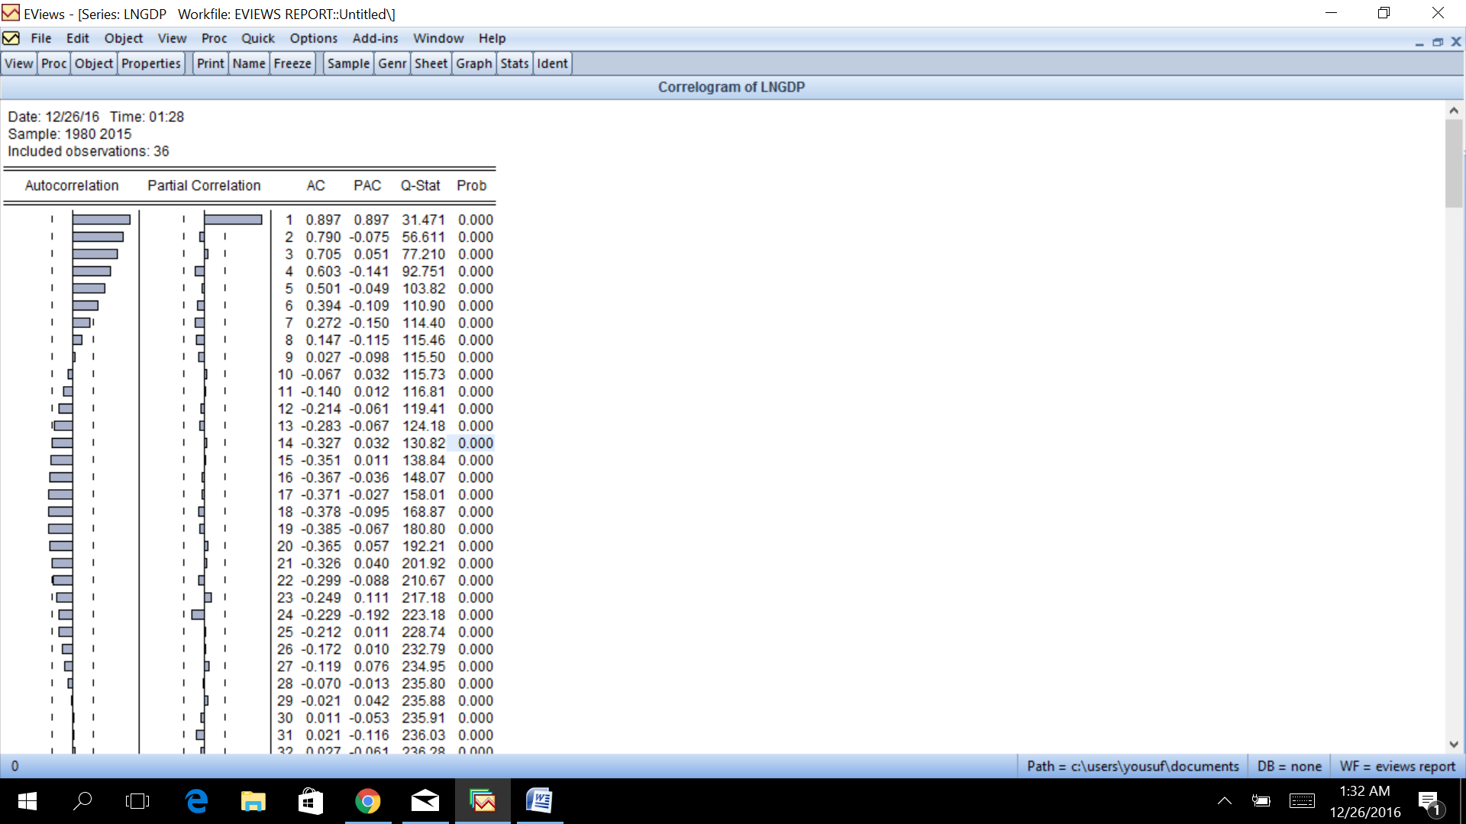  
**Interpretation:**

**STATIONARITY TESTTING THROUGH ADF ON VARIABLES:**

**LNGDP - ADF Test Results**

**At Original Level**

|  |  |  |  |  |
| --- | --- | --- | --- | --- |
| Null Hypothesis: LNGDP has a unit root | | | |  |
| Exogenous: Constant | | |  |  |
| Lag Length: 0 (Automatic - based on SIC, maxlag=9) | | | | |
|  |  |  |  |  |
|  |  |  |  |  |
|  |  |  | t-Statistic | Prob.* |
|  |  |  |  |  |
|  |  |  |  |  |
| Augmented Dickey-Fuller test statistic | | | -1.277610 | 0.6289 |
| Test critical values: | 1% level |  | -3.632900 |  |
|  | 5% level |  | -2.948404 |  |
|  | 10% level |  | -2.612874 |  |
|  |  |  |  |  |
|  |  |  |  |  |
| *MacKinnon (1996) one-sided p-values. | | | |  |
|  |  |  |  |  |
|  |  |  |  |  |
| Augmented Dickey-Fuller Test Equation | | | |  |
| Dependent Variable: D(LNGDP) | | |  |  |
| Method: Least Squares | | |  |  |
| Date: 12/26/16 Time: 00:26 | | |  |  |
| Sample (adjusted): 1981 2015 | | |  |  |
| Included observations: 35 after adjustments | | | |  |
|  |  |  |  |  |
|  |  |  |  |  |
| Variable | Coefficient | Std. Error | t-Statistic | Prob. |
|  |  |  |  |  |
|  |  |  |  |  |
| LNGDP(-1) | -0.096354 | 0.075418 | -1.277610 | 0.2103 |
| C | 2.329880 | 1.821750 | 1.278924 | 0.2098 |
|  |  |  |  |  |
|  |  |  |  |  |
| R-squared | 0.047132 | Mean dependent var | | 0.003143 |
| Adjusted R-squared | 0.018257 | S.D. dependent var | | 0.276169 |
| S.E. of regression | 0.273636 | Akaike info criterion | | 0.301411 |
| Sum squared resid | 2.470934 | Schwarz criterion | | 0.390288 |
| Log likelihood | -3.274690 | Hannan-Quinn criter. | | 0.332091 |
| F-statistic | 1.632289 | Durbin-Watson stat | | 1.849306 |
| Prob(F-statistic) | 0.210302 |  |  |  |

**Interpretation**

Above results i.e probability 62.8%, show that the LNGDP has unit root or is Non Stationary at original level

**LNGDP - ADF Test Results**

**At First Difference:**

|  |  |  |  |  |
| --- | --- | --- | --- | --- |
| Null Hypothesis: D(LNGDP) has a unit root | | | |  |
| Exogenous: Constant, Linear Trend | | | |  |
| Lag Length: 0 (Fixed) | | |  |  |
|  |  |  |  |  |
|  |  |  |  |  |
|  |  |  | t-Statistic | Prob.* |
|  |  |  |  |  |
|  |  |  |  |  |
| Augmented Dickey-Fuller test statistic | | | -5.364474 | 0.0006 |
| Test critical values: | 1% level |  | -4.252879 |  |
|  | 5% level |  | -3.548490 |  |
|  | 10% level |  | -3.207094 |  |
|  |  |  |  |  |
|  |  |  |  |  |
| *MacKinnon (1996) one-sided p-values. | | | |  |
|  |  |  |  |  |
|  |  |  |  |  |
| Augmented Dickey-Fuller Test Equation | | | |  |
| Dependent Variable: D(LNGDP,2) | | | |  |
| Method: Least Squares | | |  |  |
| Date: 12/26/16 Time: 00:31 | | |  |  |
| Sample (adjusted): 1982 2015 | | |  |  |
| Included observations: 34 after adjustments | | | |  |
|  |  |  |  |  |
|  |  |  |  |  |
| Variable | Coefficient | Std. Error | t-Statistic | Prob. |
|  |  |  |  |  |
|  |  |  |  |  |
| D(LNGDP(-1)) | -1.107334 | 0.206420 | -5.364474 | 0.0000 |
| C | -0.051047 | 0.106847 | -0.477759 | 0.6362 |
| @TREND(1980) | 0.003154 | 0.005191 | 0.607505 | 0.5479 |
|  |  |  |  |  |
|  |  |  |  |  |
| R-squared | 0.487146 | Mean dependent var | | -0.019412 |
| Adjusted R-squared | 0.454059 | S.D. dependent var | | 0.388040 |
| S.E. of regression | 0.286715 | Akaike info criterion | | 0.423439 |
| Sum squared resid | 2.548366 | Schwarz criterion | | 0.558118 |
| Log likelihood | -4.198470 | Hannan-Quinn criter. | | 0.469369 |
| F-statistic | 14.72302 | Durbin-Watson stat | | 1.793011 |
| Prob(F-statistic) | 0.000032 |  |  |  |
|  |  |  |  |  |
|  |  |  |  |  |

**Interpretation**

Above results i.e probability 0%, show that the LNGDP has become Stationary at First difference level.

**LNREER - ADF Test Results**

**At Level:**

|  |  |  |  |  |
| --- | --- | --- | --- | --- |
| Null Hypothesis: LNREER has a unit root | | | |  |
| Exogenous: Constant, Linear Trend | | | |  |
| Lag Length: 0 (Fixed) | | |  |  |
|  |  |  |  |  |
|  |  |  |  |  |
|  |  |  | t-Statistic | Prob.* |
|  |  |  |  |  |
|  |  |  |  |  |
| Augmented Dickey-Fuller test statistic | | | 0.213253 | 0.9972 |
| Test critical values: | 1% level |  | -4.243644 |  |
|  | 5% level |  | -3.544284 |  |
|  | 10% level |  | -3.204699 |  |
|  |  |  |  |  |
|  |  |  |  |  |
| *MacKinnon (1996) one-sided p-values. | | | |  |
|  |  |  |  |  |
|  |  |  |  |  |
| Augmented Dickey-Fuller Test Equation | | | |  |
| Dependent Variable: D(LNREER) | | |  |  |
| Method: Least Squares | | |  |  |
| Date: 12/26/16 Time: 00:33 | | |  |  |
| Sample (adjusted): 1981 2015 | | |  |  |
| Included observations: 35 after adjustments | | | |  |
|  |  |  |  |  |
|  |  |  |  |  |
| Variable | Coefficient | Std. Error | t-Statistic | Prob. |
|  |  |  |  |  |
|  |  |  |  |  |
| LNREER(-1) | 0.013935 | 0.065343 | 0.213253 | 0.8325 |
| C | -0.132380 | 0.340962 | -0.388255 | 0.7004 |
| @TREND(1980) | 0.002811 | 0.001740 | 1.615558 | 0.1160 |
|  |  |  |  |  |
|  |  |  |  |  |
| R-squared | 0.188536 | Mean dependent var | | -0.014857 |
| Adjusted R-squared | 0.137820 | S.D. dependent var | | 0.059080 |
| S.E. of regression | 0.054858 | Akaike info criterion | | -2.886331 |
| Sum squared resid | 0.096300 | Schwarz criterion | | -2.753015 |
| Log likelihood | 53.51079 | Hannan-Quinn criter. | | -2.840310 |
| F-statistic | 3.717458 | Durbin-Watson stat | | 1.522414 |
| Prob(F-statistic) | 0.035343 |  |  |  |
|  |  |  |  |  |
|  |  |  |  |  |

**Interpretation**

Above results i.e. probability 99%, show that the LNREER has unit root or is Non Stationary at original level

**LNREER- ADF Test Results**

**At First Difference:**

|  |  |  |  |  |
| --- | --- | --- | --- | --- |
| Null Hypothesis: D(LNREER) has a unit root | | | |  |
| Exogenous: Constant, Linear Trend | | | |  |
| Lag Length: 0 (Fixed) | | |  |  |
|  |  |  |  |  |
|  |  |  |  |  |
|  |  |  | t-Statistic | Prob.* |
|  |  |  |  |  |
|  |  |  |  |  |
| Augmented Dickey-Fuller test statistic | | | -6.323442 | 0.0000 |
| Test critical values: | 1% level |  | -4.252879 |  |
|  | 5% level |  | -3.548490 |  |
|  | 10% level |  | -3.207094 |  |
|  |  |  |  |  |
|  |  |  |  |  |
| *MacKinnon (1996) one-sided p-values. | | | |  |
|  |  |  |  |  |
|  |  |  |  |  |
| Augmented Dickey-Fuller Test Equation | | | |  |
| Dependent Variable: D(LNREER,2) | | | |  |
| Method: Least Squares | | |  |  |
| Date: 12/26/16 Time: 00:40 | | |  |  |
| Sample (adjusted): 1982 2015 | | |  |  |
| Included observations: 34 after adjustments | | | |  |
|  |  |  |  |  |
|  |  |  |  |  |
| Variable | Coefficient | Std. Error | t-Statistic | Prob. |
|  |  |  |  |  |
|  |  |  |  |  |
| D(LNREER(-1)) | -0.921221 | 0.145683 | -6.323442 | 0.0000 |
| C | -0.077971 | 0.018250 | -4.272440 | 0.0002 |
| @TREND(1980) | 0.003274 | 0.000834 | 3.923137 | 0.0005 |
|  |  |  |  |  |
|  |  |  |  |  |
| R-squared | 0.579594 | Mean dependent var | | -0.000882 |
| Adjusted R-squared | 0.552471 | S.D. dependent var | | 0.066075 |
| S.E. of regression | 0.044202 | Akaike info criterion | | -3.315978 |
| Sum squared resid | 0.060569 | Schwarz criterion | | -3.181299 |
| Log likelihood | 59.37163 | Hannan-Quinn criter. | | -3.270049 |
| F-statistic | 21.36910 | Durbin-Watson stat | | 1.817478 |
| Prob(F-statistic) | 0.000001 |  |  |  |
|  |  |  |  |  |
|  |  |  |  |  |

**Interpretation:**

Above results i.e. probability 0%, show that the LNREER have become Stationary at First difference level.

**LNOIL- ADF Test Results**

**At LEVEL:**

|  |  |  |  |  |
| --- | --- | --- | --- | --- |
| Null Hypothesis: LNOIL has a unit root | | | |  |
| Exogenous: Constant, Linear Trend | | | |  |
| Lag Length: 0 (Fixed) | | |  |  |
|  |  |  |  |  |
|  |  |  |  |  |
|  |  |  | t-Statistic | Prob.* |
|  |  |  |  |  |
|  |  |  |  |  |
| Augmented Dickey-Fuller test statistic | | | -2.229350 | 0.4595 |
| Test critical values: | 1% level |  | -4.243644 |  |
|  | 5% level |  | -3.544284 |  |
|  | 10% level |  | -3.204699 |  |
|  |  |  |  |  |
|  |  |  |  |  |
| *MacKinnon (1996) one-sided p-values. | | | |  |
|  |  |  |  |  |
|  |  |  |  |  |
| Augmented Dickey-Fuller Test Equation | | | |  |
| Dependent Variable: D(LNOIL) | | |  |  |
| Method: Least Squares | | |  |  |
| Date: 12/26/16 Time: 00:42 | | |  |  |
| Sample (adjusted): 1981 2015 | | |  |  |
| Included observations: 35 after adjustments | | | |  |
|  |  |  |  |  |
|  |  |  |  |  |
| Variable | Coefficient | Std. Error | t-Statistic | Prob. |
|  |  |  |  |  |
|  |  |  |  |  |
| LNOIL(-1) | -0.214334 | 0.096142 | -2.229350 | 0.0329 |
| C | 0.540849 | 0.276210 | 1.958105 | 0.0590 |
| @TREND(1980) | 0.010922 | 0.005829 | 1.873819 | 0.0701 |
|  |  |  |  |  |
|  |  |  |  |  |
| R-squared | 0.141459 | Mean dependent var | | 0.003143 |
| Adjusted R-squared | 0.087800 | S.D. dependent var | | 0.275902 |
| S.E. of regression | 0.263512 | Akaike info criterion | | 0.252382 |
| Sum squared resid | 2.222037 | Schwarz criterion | | 0.385697 |
| Log likelihood | -1.416683 | Hannan-Quinn criter. | | 0.298402 |
| F-statistic | 2.636265 | Durbin-Watson stat | | 1.858183 |
| Prob(F-statistic) | 0.087132 |  |  |  |
|  |  |  |  |  |
|  |  |  |  |  |

**Interpretation**

Above results i.e. probability 45.9%, show that the LNOIL has unit root or is Non Stationary at original level

**LNOIL- ADF Test Results**

**At FIRST DIFFERENCE:**

|  |  |  |  |  |
| --- | --- | --- | --- | --- |
| Null Hypothesis: D(LNOIL) has a unit root | | | |  |
| Exogenous: Constant, Linear Trend | | | |  |
| Lag Length: 0 (Fixed) | | |  |  |
|  |  |  |  |  |
|  |  |  |  |  |
|  |  |  | t-Statistic | Prob.* |
|  |  |  |  |  |
|  |  |  |  |  |
| Augmented Dickey-Fuller test statistic | | | -5.366185 | 0.0006 |
| Test critical values: | 1% level |  | -4.252879 |  |
|  | 5% level |  | -3.548490 |  |
|  | 10% level |  | -3.207094 |  |
|  |  |  |  |  |
|  |  |  |  |  |
| *MacKinnon (1996) one-sided p-values. | | | |  |
|  |  |  |  |  |
|  |  |  |  |  |
| Augmented Dickey-Fuller Test Equation | | | |  |
| Dependent Variable: D(LNOIL,2) | | | |  |
| Method: Least Squares | | |  |  |
| Date: 12/26/16 Time: 00:45 | | |  |  |
| Sample (adjusted): 1982 2015 | | |  |  |
| Included observations: 34 after adjustments | | | |  |
|  |  |  |  |  |
|  |  |  |  |  |
| Variable | Coefficient | Std. Error | t-Statistic | Prob. |
|  |  |  |  |  |
|  |  |  |  |  |
| D(LNOIL(-1)) | -1.111852 | 0.207196 | -5.366185 | 0.0000 |
| C | -0.051024 | 0.106721 | -0.478107 | 0.6359 |
| @TREND(1980) | 0.003144 | 0.005186 | 0.606314 | 0.5487 |
|  |  |  |  |  |
|  |  |  |  |  |
| R-squared | 0.487313 | Mean dependent var | | -0.020000 |
| Adjusted R-squared | 0.454237 | S.D. dependent var | | 0.387713 |
| S.E. of regression | 0.286426 | Akaike info criterion | | 0.421424 |
| Sum squared resid | 2.543235 | Schwarz criterion | | 0.556103 |
| Log likelihood | -4.164206 | Hannan-Quinn criter. | | 0.467353 |
| F-statistic | 14.73288 | Durbin-Watson stat | | 1.786646 |
| Prob(F-statistic) | 0.000032 |  |  |  |
|  |  |  |  |  |
|  |  |  |  |  |

**Interpretation:**

Above results i.e. probability 0%, show that the LNOIL have become Stationary at First difference level.

**USINF- ADF Test Results**

**At LEVEL:**

|  |  |  |  |  |
| --- | --- | --- | --- | --- |
| Null Hypothesis: USINF has a unit root | | | |  |
| Exogenous: Constant, Linear Trend | | | |  |
| Lag Length: 0 (Fixed) | | |  |  |
|  |  |  |  |  |
|  |  |  |  |  |
|  |  |  | t-Statistic | Prob.* |
|  |  |  |  |  |
|  |  |  |  |  |
| Augmented Dickey-Fuller test statistic | | | -10.31347 | 0.0000 |
| Test critical values: | 1% level |  | -4.243644 |  |
|  | 5% level |  | -3.544284 |  |
|  | 10% level |  | -3.204699 |  |
|  |  |  |  |  |
|  |  |  |  |  |
| *MacKinnon (1996) one-sided p-values. | | | |  |
|  |  |  |  |  |
|  |  |  |  |  |
| Augmented Dickey-Fuller Test Equation | | | |  |
| Dependent Variable: D(USINF) | | |  |  |
| Method: Least Squares | | |  |  |
| Date: 12/26/16 Time: 00:48 | | |  |  |
| Sample (adjusted): 1981 2015 | | |  |  |
| Included observations: 35 after adjustments | | | |  |
|  |  |  |  |  |
|  |  |  |  |  |
| Variable | Coefficient | Std. Error | t-Statistic | Prob. |
|  |  |  |  |  |
|  |  |  |  |  |
| USINF(-1) | -0.451602 | 0.043788 | -10.31347 | 0.0000 |
| C | 2.086400 | 0.328644 | 6.348516 | 0.0000 |
| @TREND(1980) | -0.050654 | 0.010511 | -4.819221 | 0.0000 |
|  |  |  |  |  |
|  |  |  |  |  |
| R-squared | 0.802574 | Mean dependent var | | -0.397714 |
| Adjusted R-squared | 0.790235 | S.D. dependent var | | 0.876393 |
| S.E. of regression | 0.401389 | Akaike info criterion | | 1.094046 |
| Sum squared resid | 5.155626 | Schwarz criterion | | 1.227362 |
| Log likelihood | -16.14581 | Hannan-Quinn criter. | | 1.140067 |
| F-statistic | 65.04301 | Durbin-Watson stat | | 1.956806 |
| Prob(F-statistic) | 0.000000 |  |  |  |
|  |  |  |  |  |
|  |  |  |  |  |

**Interpretation:**

Above results i.e. probability 0%, show that the USINF have become Stationary at level.

**ERROR TERM - ADF Test Results**

|  |  |  |  |  |
| --- | --- | --- | --- | --- |
| Null Hypothesis: ET has a unit root | | | |  |
| Exogenous: None | | |  |  |
| Lag Length: 0 (Fixed) | | |  |  |
|  |  |  |  |  |
|  |  |  |  |  |
|  |  |  | t-Statistic | Prob.* |
|  |  |  |  |  |
|  |  |  |  |  |
| Augmented Dickey-Fuller test statistic | | | -7.669350 | 0.0000 |
| Test critical values: | 1% level |  | -2.632688 |  |
|  | 5% level |  | -1.950687 |  |
|  | 10% level |  | -1.611059 |  |
|  |  |  |  |  |
|  |  |  |  |  |
| *MacKinnon (1996) one-sided p-values. | | | |  |
|  |  |  |  |  |
|  |  |  |  |  |
| Augmented Dickey-Fuller Test Equation | | | |  |
| Dependent Variable: D(ET) | | |  |  |
| Method: Least Squares | | |  |  |
| Date: 12/26/16 Time: 00:52 | | |  |  |
| Sample (adjusted): 1981 2015 | | |  |  |
| Included observations: 35 after adjustments | | | |  |
|  |  |  |  |  |
|  |  |  |  |  |
| Variable | Coefficient | Std. Error | t-Statistic | Prob. |
|  |  |  |  |  |
|  |  |  |  |  |
| ET(-1) | -1.310229 | 0.170840 | -7.669350 | 0.0000 |
|  |  |  |  |  |
|  |  |  |  |  |
| R-squared | 0.633621 | Mean dependent var | | 8.33E-05 |
| Adjusted R-squared | 0.633621 | S.D. dependent var | | 0.005920 |
| S.E. of regression | 0.003583 | Akaike info criterion | | -8.396907 |
| Sum squared resid | 0.000437 | Schwarz criterion | | -8.352468 |
| Log likelihood | 147.9459 | Hannan-Quinn criter. | | -8.381566 |
| Durbin-Watson stat | 1.732111 |  |  |  |
|  |  |  |  |  |
|  |  |  |  |  |

**Interpretation**

Above results of probability < 1% shows that the Error Term is Stationary at original level. Hence, the co-integration exists. In other words, Coefficient value of-1.31 shows that the extent of disequilibrium reduces by 131% per year.